**Blank Solution Naming Requirements**

Create Blank Solution.

Name it in this format: [CourseName-MyName-FacultyNumber-H1]

Ex: ITMOM-DeividMladenov-00001001-H1

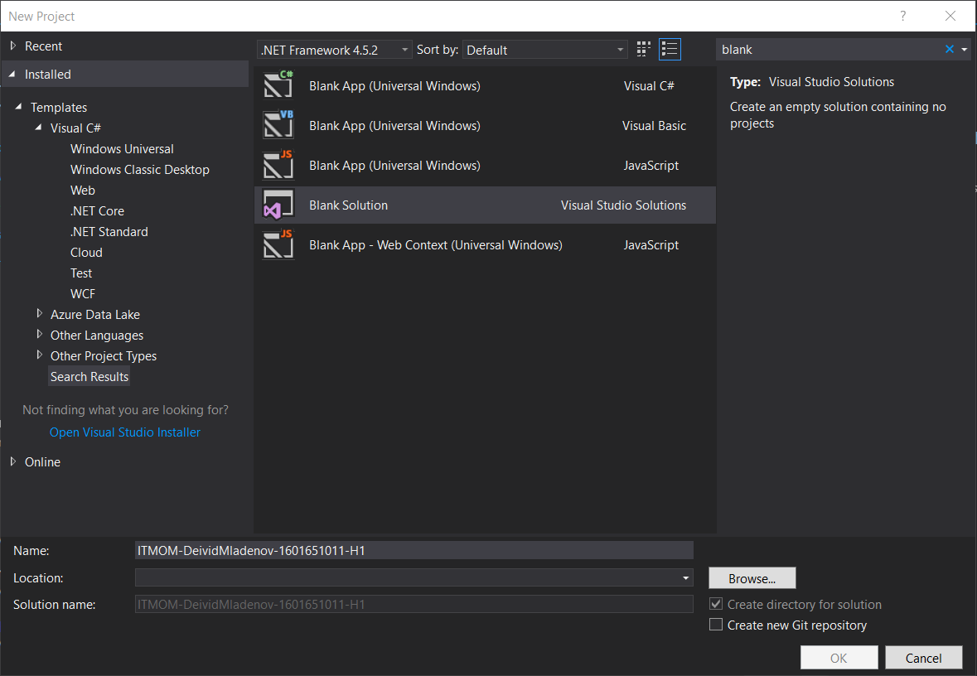

Location is your own choice.

**Some Hints !?!**

1. Use Visual Studio 2017.
2. H1 at the end of the name is the number of the current homework. In other words H1 = Homework 1.
3. Remember this format of naming for your homework !!!
4. Use our YouTube channel or GitHub repository if you need more help .